Cyber Security Task-8

Objective: Understand the role of VPNs in protecting privacy and secure communication.

--------------------------------------------------------

1. **Choosing a Reputable Free VPN Service.**

After researching several options, I selected **Proton VPN** for its strong privacy policies, unlimited data on free servers, and support for secure protocols like WireGuard. It’s a well-known provider with a transparent no-logs policy and open-source apps.

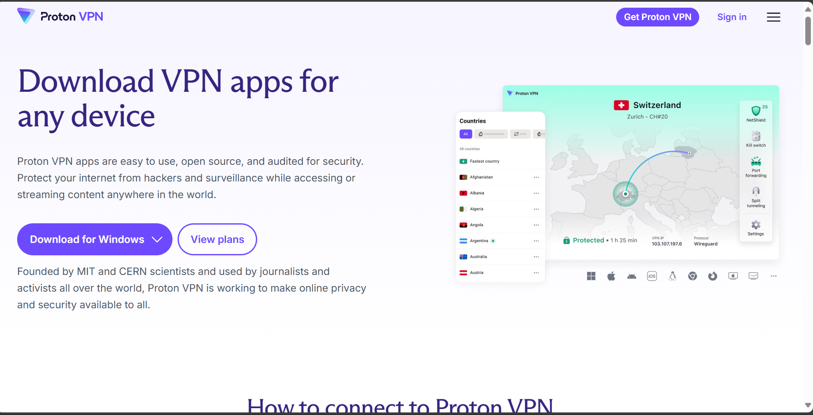

--------------------------------------------------------

1. **Downloading and Installing the VPN Client.**

I downloaded the Proton VPN client from the official website and installed it on my device. The installation process was straightforward, with clear instructions and a clean user interface.

--------------------------------------------------------

1. **Connecting to a VPN Server.**

I launched the app and connected to the **fastest free server**, which was located in the Netherlands (NL-FREE#147). The server used the **WireGuard (UDP)** protocol, known for its speed and security.

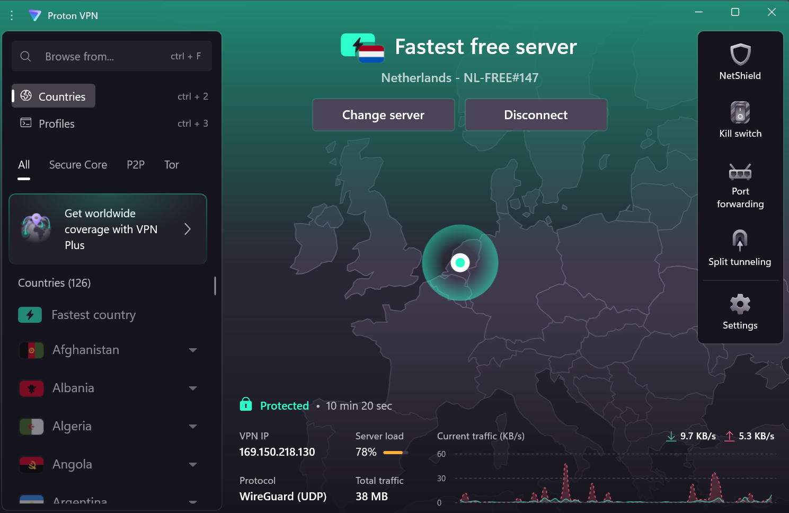

--------------------------------------------------------

1. **Verifying IP Address Change.**

To confirm the VPN was working, I visited WhatIsMyIPAddress.com. My IP address had successfully changed to **169.150.218.130**, and the location showed as **Amsterdam, Netherlands**, verifying that my traffic was being routed through the VPN.

Before connecting:

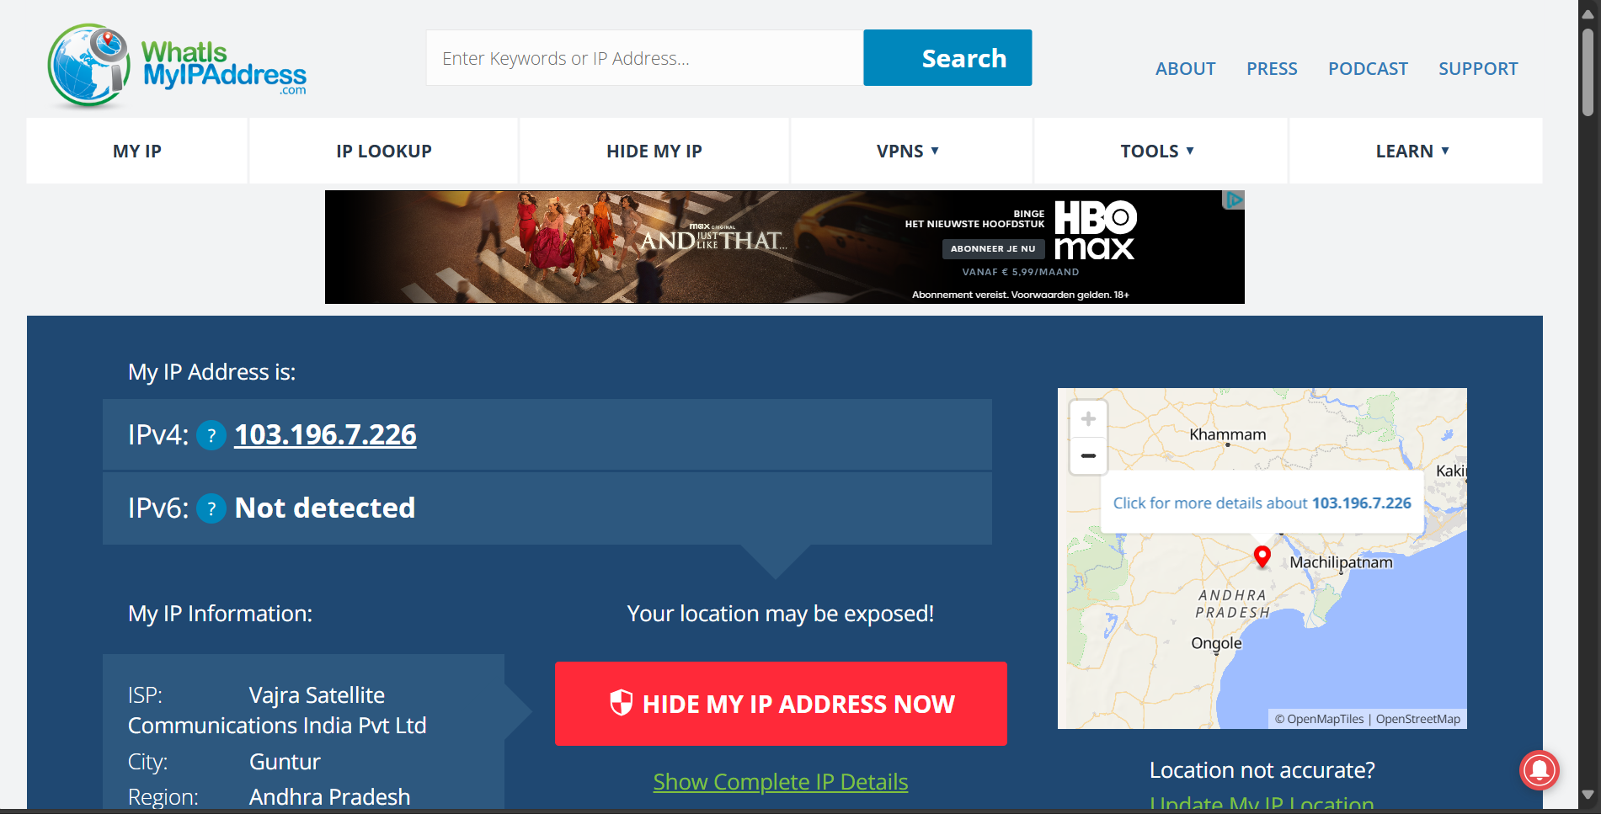

After connecting:

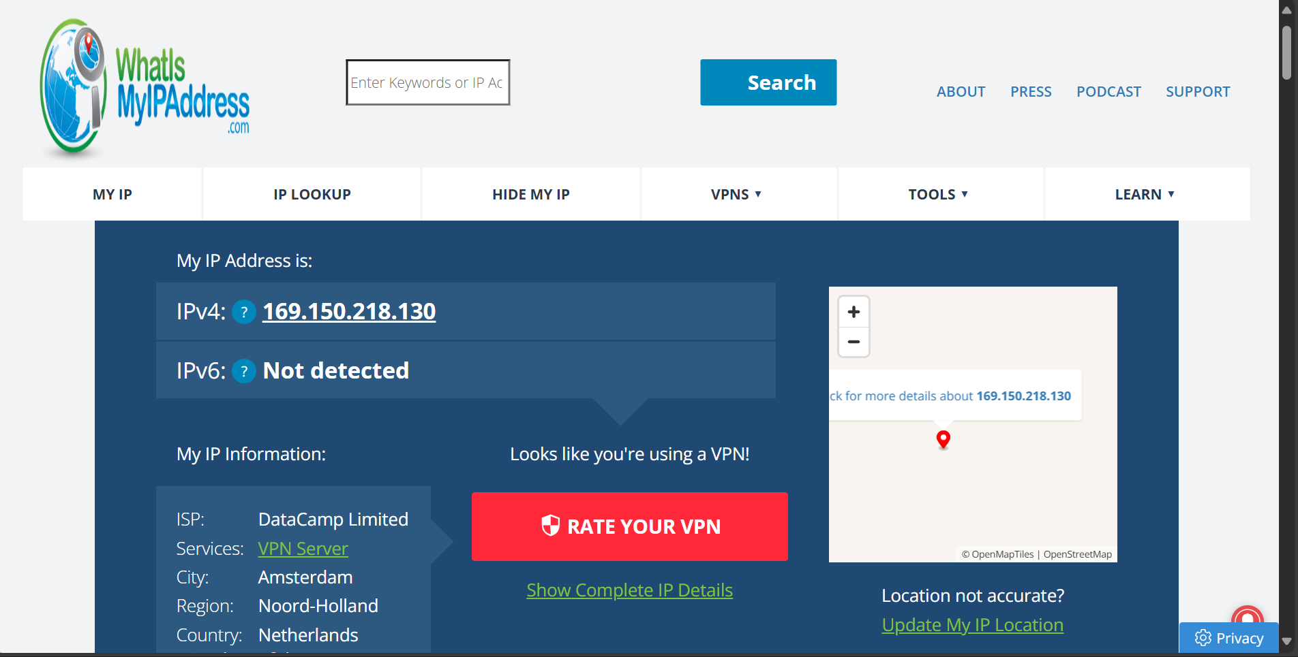

--------------------------------------------------------

1. **Browsing a Website to Confirm Encryption.**

**I visited example.com, a secure placeholder site, and confirmed that the browser displayed a padlock icon, indicating HTTPS encryption. Combined with the VPN tunnel, this ensures my data is encrypted end-to-end.**

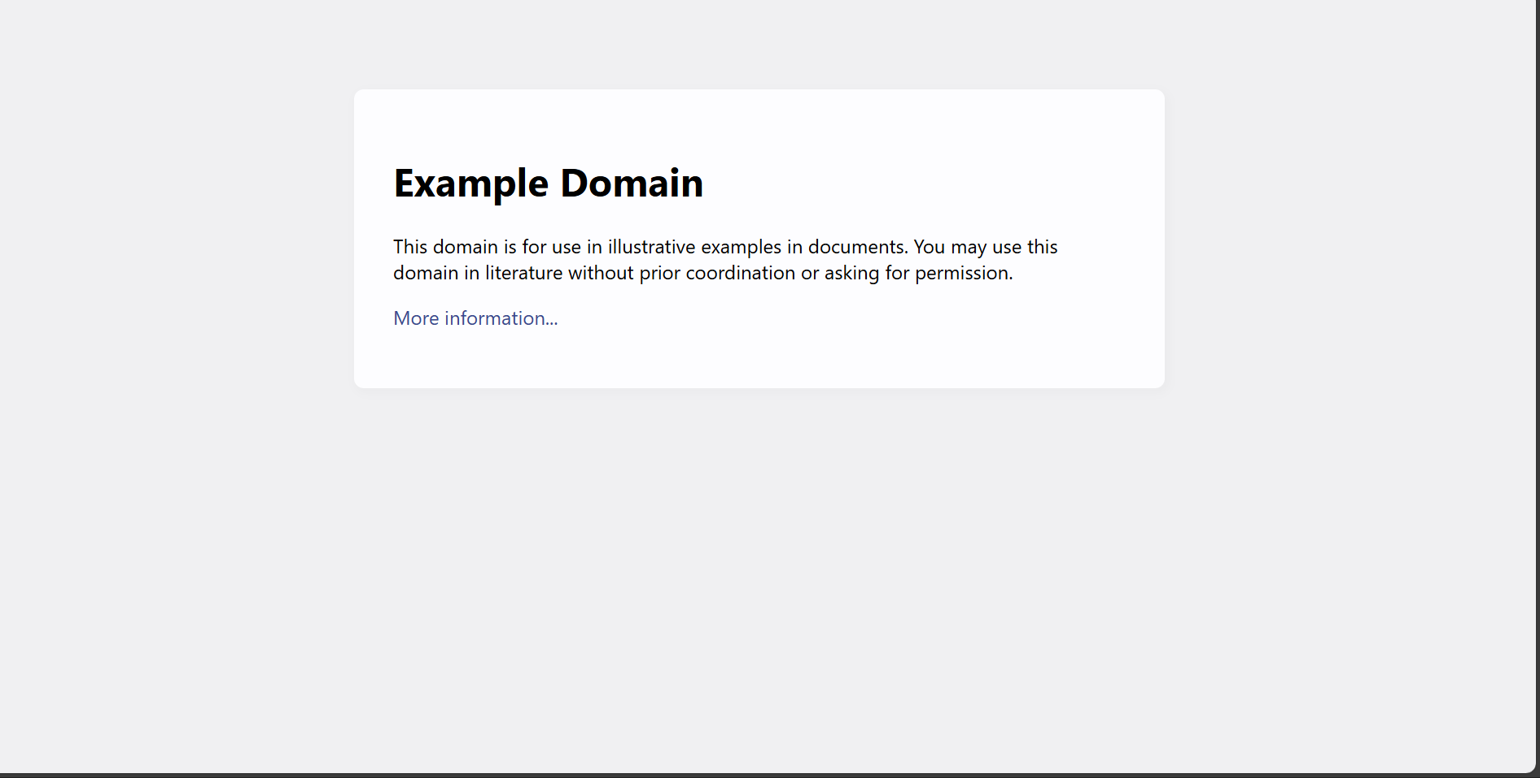

-------------------------------------------------------

1. **Disconnecting VPN and Comparing Speed/IP.**

After disconnecting from the VPN, I revisited WhatIsMyIPAddress.com and saw my original IP address restored. I also ran a speed test using Speedtest.net before and after using the VPN. While the VPN slightly reduced download speeds due to encryption overhead, the browsing experience remained smooth.

With VPN:

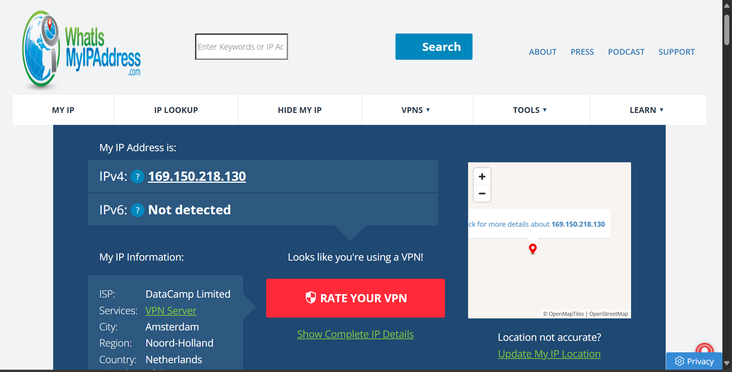

Without VPN:

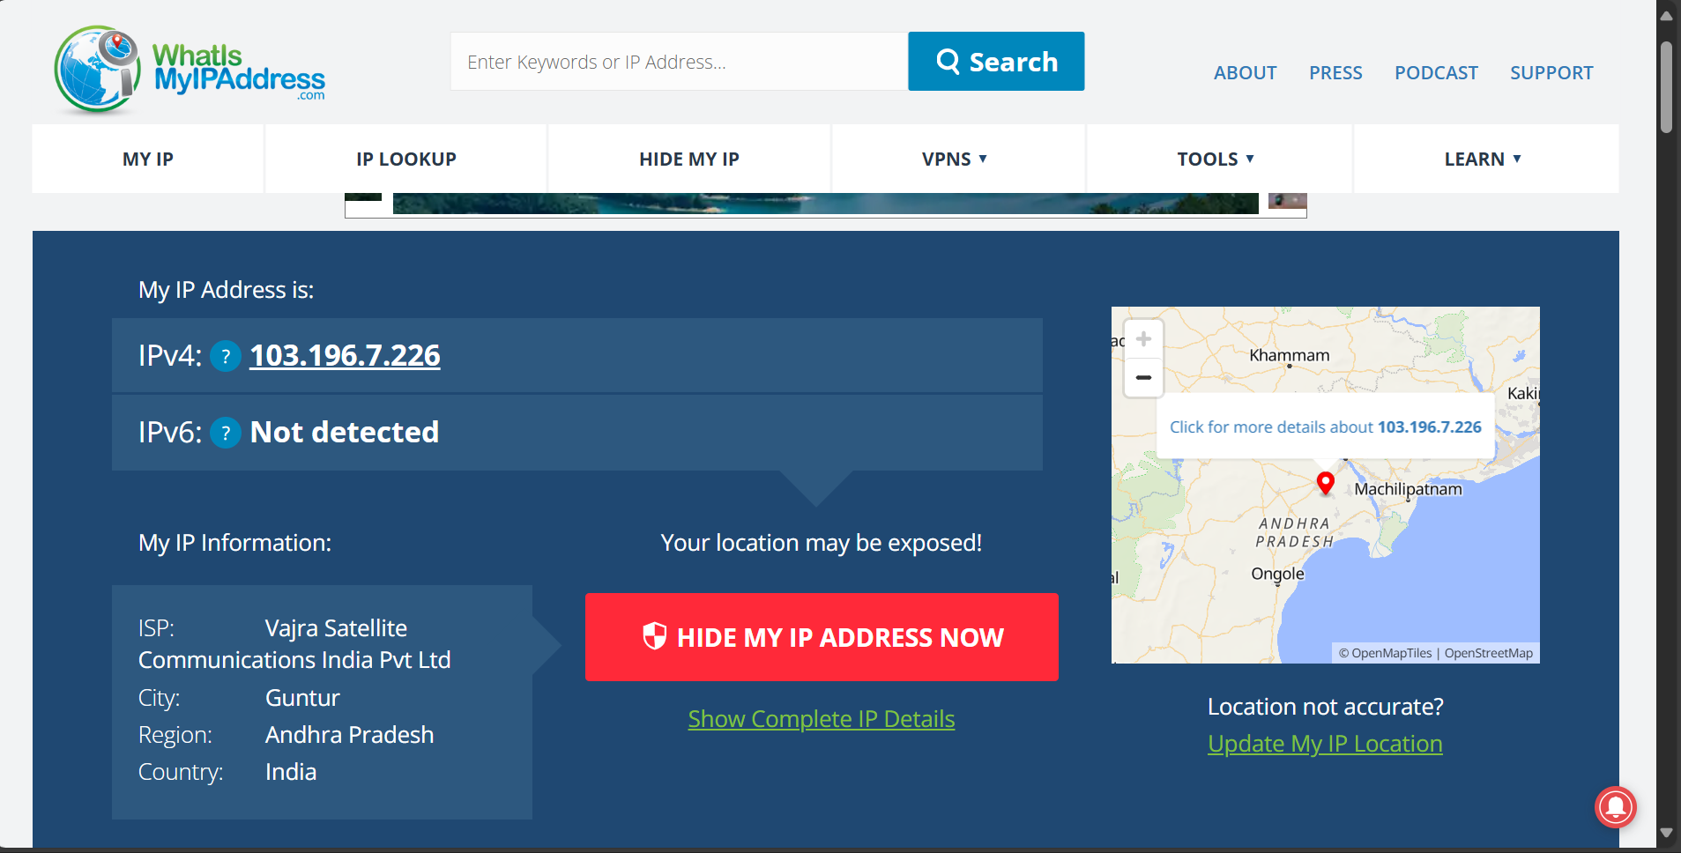

--------------------------------------------------------

Speed Test(With VPN):

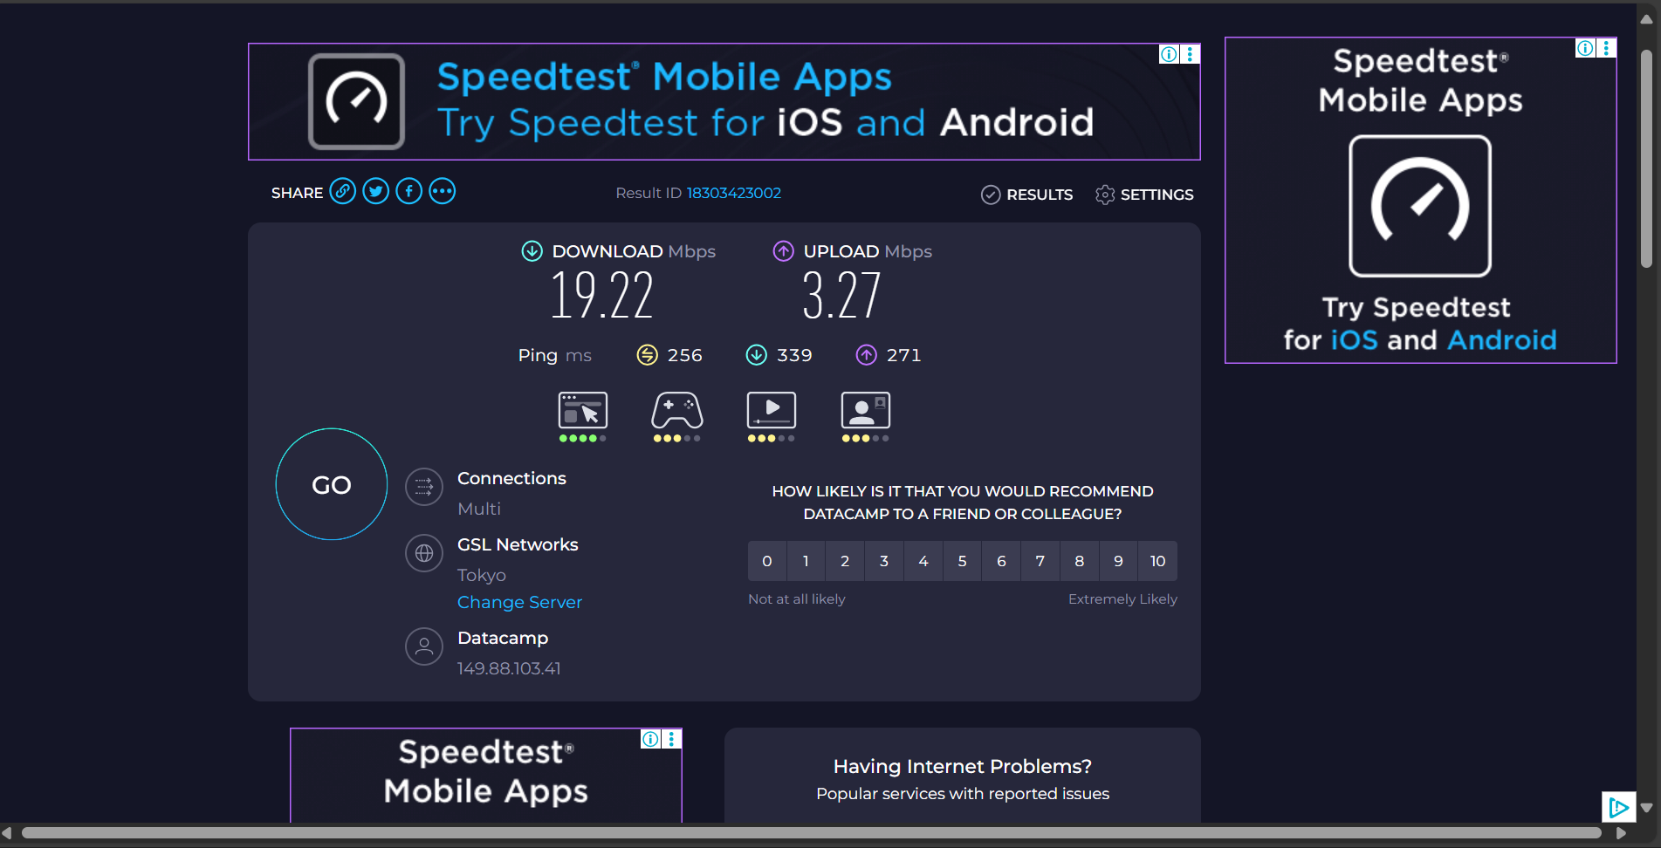

Speed Test (Without VPN):

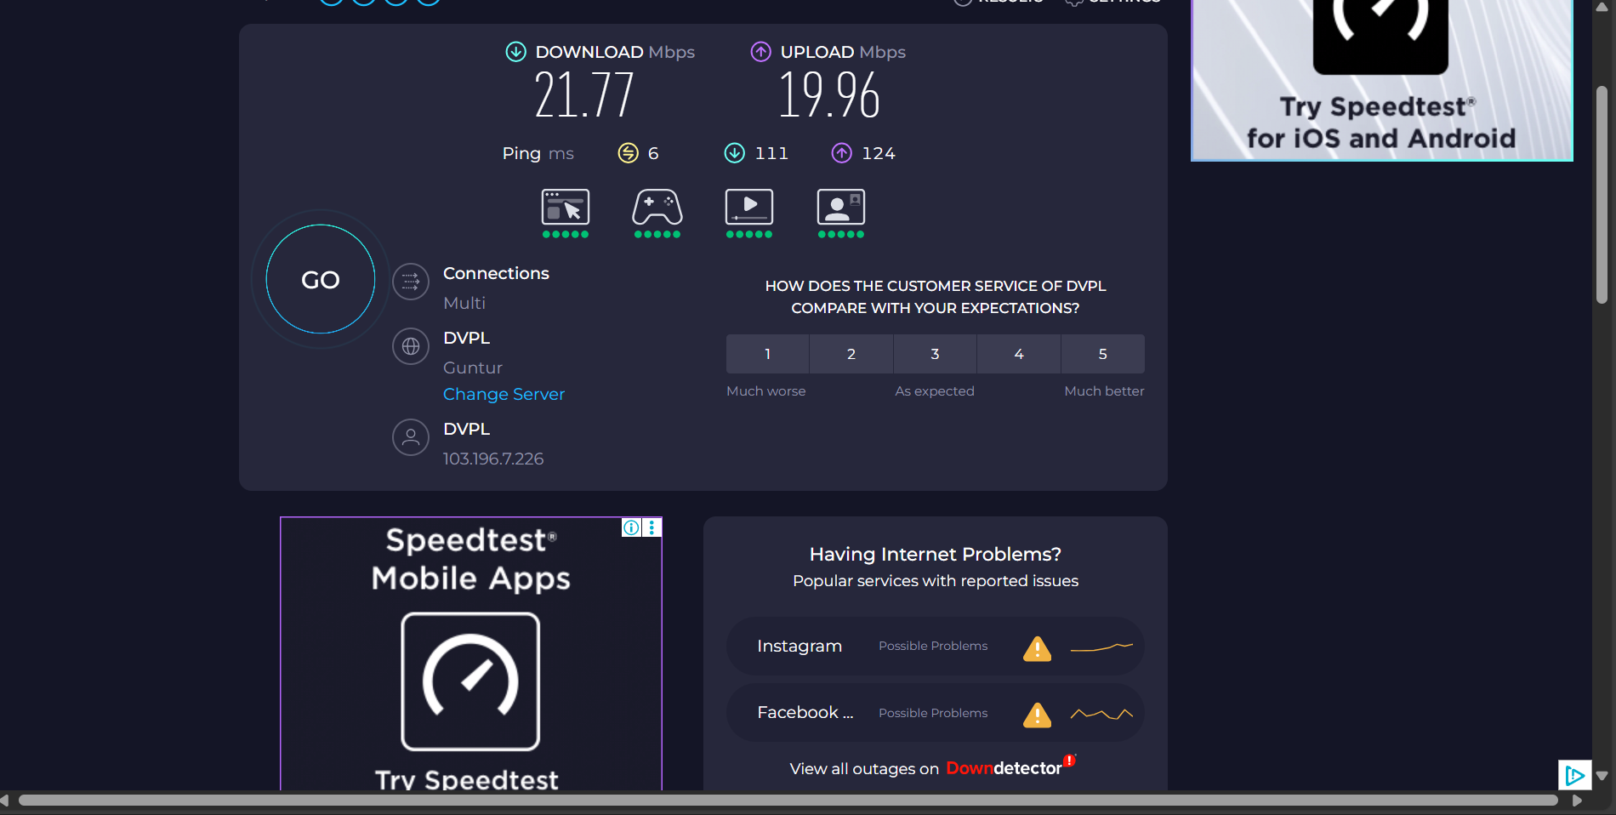

--------------------------------------------------------

1. **Researching VPN Encryption and Privacy Features.**

**Proton VPN uses AES-256 encryption, which is considered military-grade. It supports WireGuard, a modern protocol that balances speed and security. Key privacy features include:**

* **Kill Switch: Prevents data leaks if the VPN disconnects.**
* **NetShield: Blocks ads, trackers, and malware.**
* **Split Tunneling: Allows selective routing of apps through the VPN.**
* **No-Logs Policy: Ensures user activity is never stored or shared**

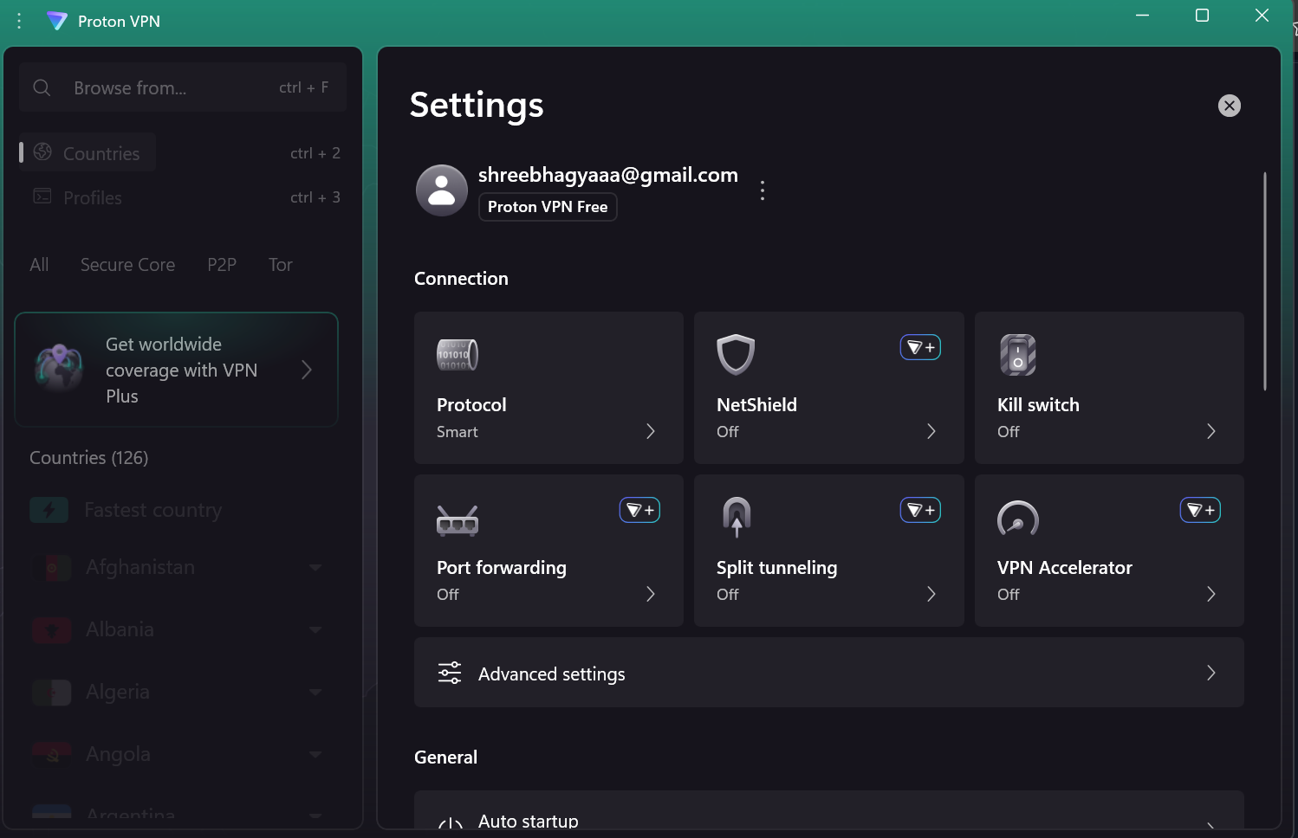

**--------------------------------------------------------**

1. **Summary: VPN Benefits and Limitations.**

**✅ Benefits**

* **Enhanced Privacy: Masks your IP and encrypts traffic, protecting you from surveillance and tracking.**
* **Access to Geo-Restricted Content: Enables streaming and browsing from other regions.**
* **Secure Public Wi-Fi Use: Protects sensitive data on open networks.**
* **Bypass Censorship: Useful in countries with restricted internet access.**

**⚠️ Limitations**

* **Reduced Speed: Encryption and server distance can slow performance.**
* **Limited Free Features: Fewer server options and slower speeds compared to paid plans.**
* **Not a Full Security Solution: VPNs don’t protect against phishing or malware.**
* **Legal Restrictions: VPN use may be regulated or monitored in some countries.**